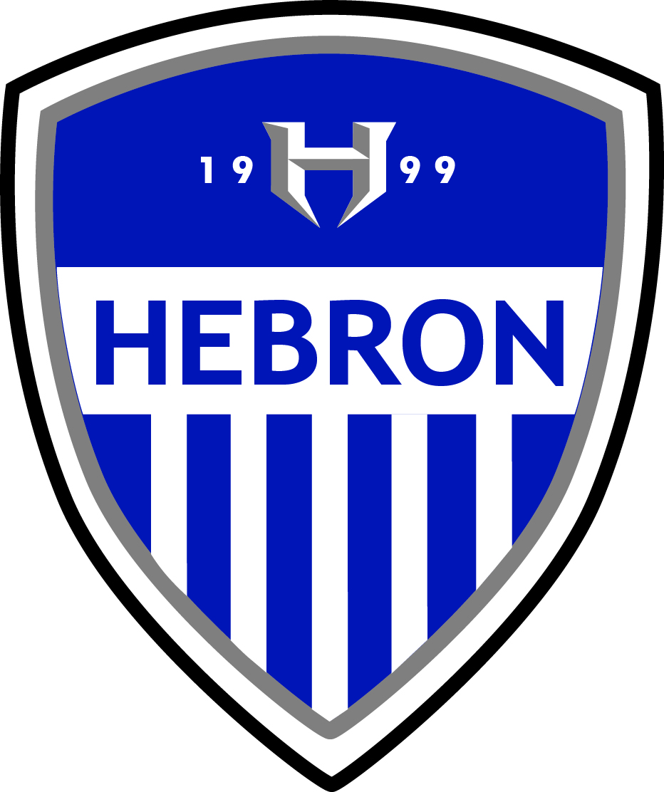 Hebron High School Soccer Booster Club

Scholarship Application / Questionnaire – Class of 2020

NAME: ______________________________________________ Jersey #: _____

When were you a participant in the Hebron Soccer Program (please circle each) : 9th - 10th - 11th - 1 2th

Has your family been a member of the Soccer Booster Club? (please circle each) : 9th - 10th - 11th - 1 2th

Have you participated in Soccer Booster Club all Fundraisers? (please circle each) : 9th - 10th - 11th - 1 2th

What College do you plan to attend? (Name of institution or “undecided”):

___________________________________________________________

What do you plan to study? (Name of major/discipline or “undecided”): ___________________________

Do you plan to continue playing soccer at the collegiate level? (please circle) Y or N

List of High School Honors (athletic, academic, etc.): ________________________________________

_________________________________________________________________________________

_________________________________________________________________________________

_________________________________________________________________________________

Name of Team/Club (outside of High School soccer) if applicable: ________________________________

List any outside activities, honors received (volunteer/service work, outside activities/associations/memberships/involvement, etc. (if any – may choose not to disclose if you wish):

_________________________________________________________________________________

_________________________________________________________________________________

_________________________________________________________________________________

Parental / family involvement with Hebron Soccer Booster Club (past or present):

_________________________________________________________________________________

_________________________________________________________________________________

ESSAY:

On a separate page, please write a short essay answering one of the following prompts:

*(Please limit to 750 words or less)

1. How has soccer enhanced / impacted / influenced your life?
2. How could you help / influence the soccer community in the future?