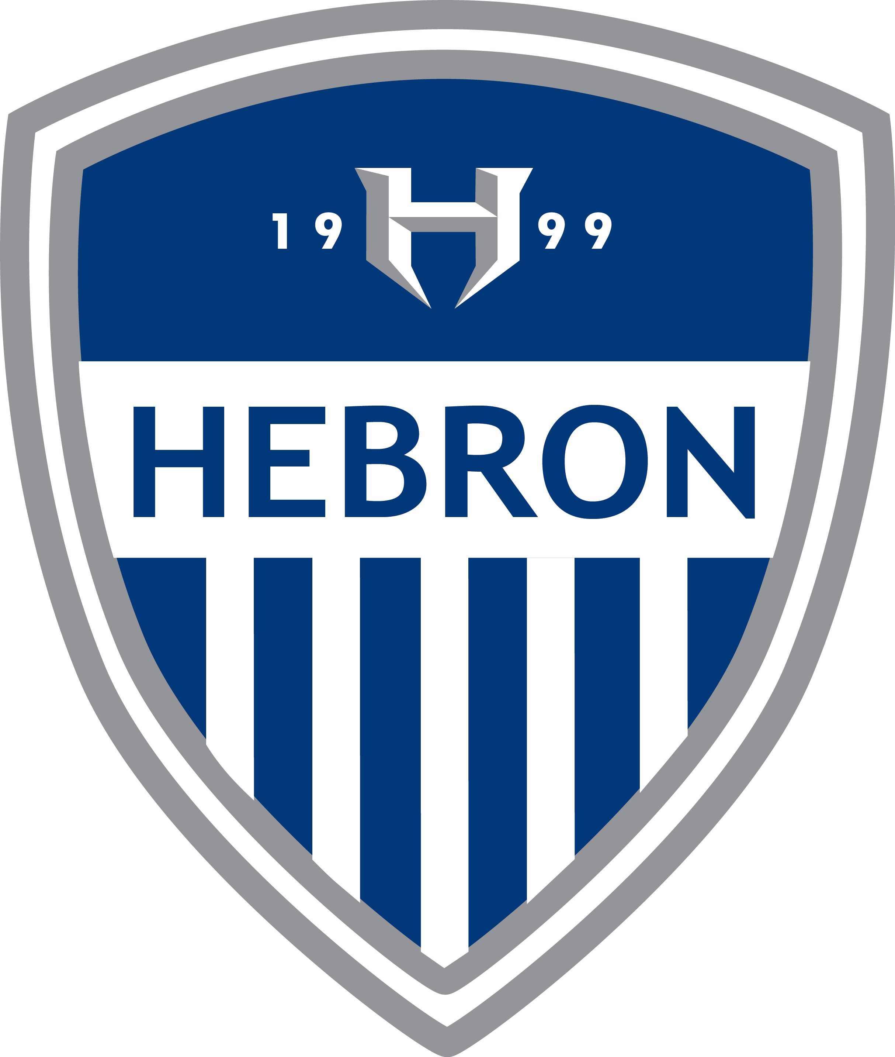
Hebron Soccer 2021/2022

Date Opponent Venue
Dec. 10 Sachse (Scrimmage) Away
Dec. 14 Prosper (Scrimmage) Home
Dec. 16 Allen (Scrimmage) Away (Eagle Stadium)
Jan. 3 Irving (Scrimmage) Home (TBD)
Jan. 6-8 NTX Showcase (Varsity) Home (TBD)
Jan. 13-15 Georgetown Showcase (Varsity) Away
Jan. 13-15 Allen Showcase (JV1 & JV2) Allen (TBD)
Jan. 18 Prosper Rock Hill (Varsity & JV1) Away
Jan. 20-22 Rockwall JV Tourney (JV1 & JV2) Rockwall (TBD)

District
Jan. 25 Plano East Home *****
Jan. 28 Flower Mound @ Flower Mound
Feb. 1 Plano Home. ******
Feb. 4 Coppell @ Coppell
Feb. 8 Marcus Home
Feb. 11 Plano West Home
Feb. 11 Flower Mound Home (JV2)
Feb. 15 Lewisville @ Lewisville
Feb. 18 Plano East @ Plano East
Feb. 22 Flower Mound Home
Feb. 25 Plano @ Plano. *****
Mar. 1 Coppell Home
Mar. 4 Marcus @ Marcus
Mar. 8 Plano West @ Plano West
Mar. 8 Coppell @ Coppell
Mar. 15 Lewisville Home

*Game times are: 4:30, 6:00 and 7:30 unless otherwise noted (JV2, JV, V)
****** = No JV2 game scheduled
Head Coach-Matt Zimmerman Asst. Coaches- John Summers, Beck Nitcholas, Eric Congdon
Principal- Amy Boughton Athletic Coordinators-Brian Brazil and Karin Keeney
Athletic Trainers- Kristi Wenth, Nikki Briseno, Matt Moreau

